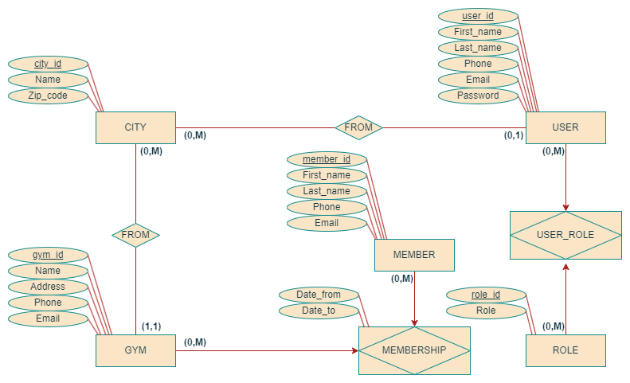

|  |  |  |
| --- | --- | --- |
| ENTITY | ATTRIBUTE | NOTE |
| City | city_id#, Long, AUTO_INCREMENT  Name, String, Not Null  Zip_code, String , Not Null (Length = 5) |  |
| Member | member_id#, Long, AUTO_INCREMENT  First_name, String, Not Null  Last_Name, String, Not Null  Phone, String, Null  Email, String, Null |  |
| Role | role_id#, Long, AUTO_INCREMENT  Role, String, Not Null |  |
| User | user_id#, Long, AUTO_INCREMENT  First_name, String, Not Null  Last_Name, String, Not Null  Phone, String, Null  Email, String, Not Null  Password, String, Not Null |  |
| Gym | gym_id#, Long, AUTO_INCREMENT  Name, String, Not Null  Address, String, Not Null  Phone, String, Not Null  Email, String, Not Null |  |
| User_Role | UserId, Long Not Null  RoleId, Long, Not Null |  |
| Membership | GymId, Long, Not Null  MemberId, Long, Not Null  Date_from, Date, Not Null  Date_to, Date, Not Null |  |

